Lists

Look at this code:
item = input("Pack one item: ")
packing_list = ["water", "map"]
packing_list.append(item)
print("Packing list:", packing_list)

What do you think this code will do if the user enters 'torch'?
Click or tap here to enter text.

Run the code. Compare the result with your prediction:
Click or tap here to enter text.

Let’s investigate! Answer the questions below:
- If you enter compass, what exact list is printed?
Click or tap here to enter text.

- Why does append(item) add one item instead of joining the characters of item separately?
Click or tap here to enter text.

- Which line adds the new item to packing_list?
Click or tap here to enter text.

- Why is the new item placed at the end rather than at position 0?
Click or tap here to enter text.

Lists

Look at this code:
item = input("Pack one item: ")
packing_list = ["water", "map"]
packing_list.append(item)
print("Packing list:", packing_list)

Use the code above to help you. After completing each challenge below, run your program to test that it works correctly. Save each completed challenge program in a new file.

Programming Challenges

Challenge 1
Prepare the starter for a weekend trip by replacing the initial list with three useful items. The user's extra item must still be appended and visible in the final list.
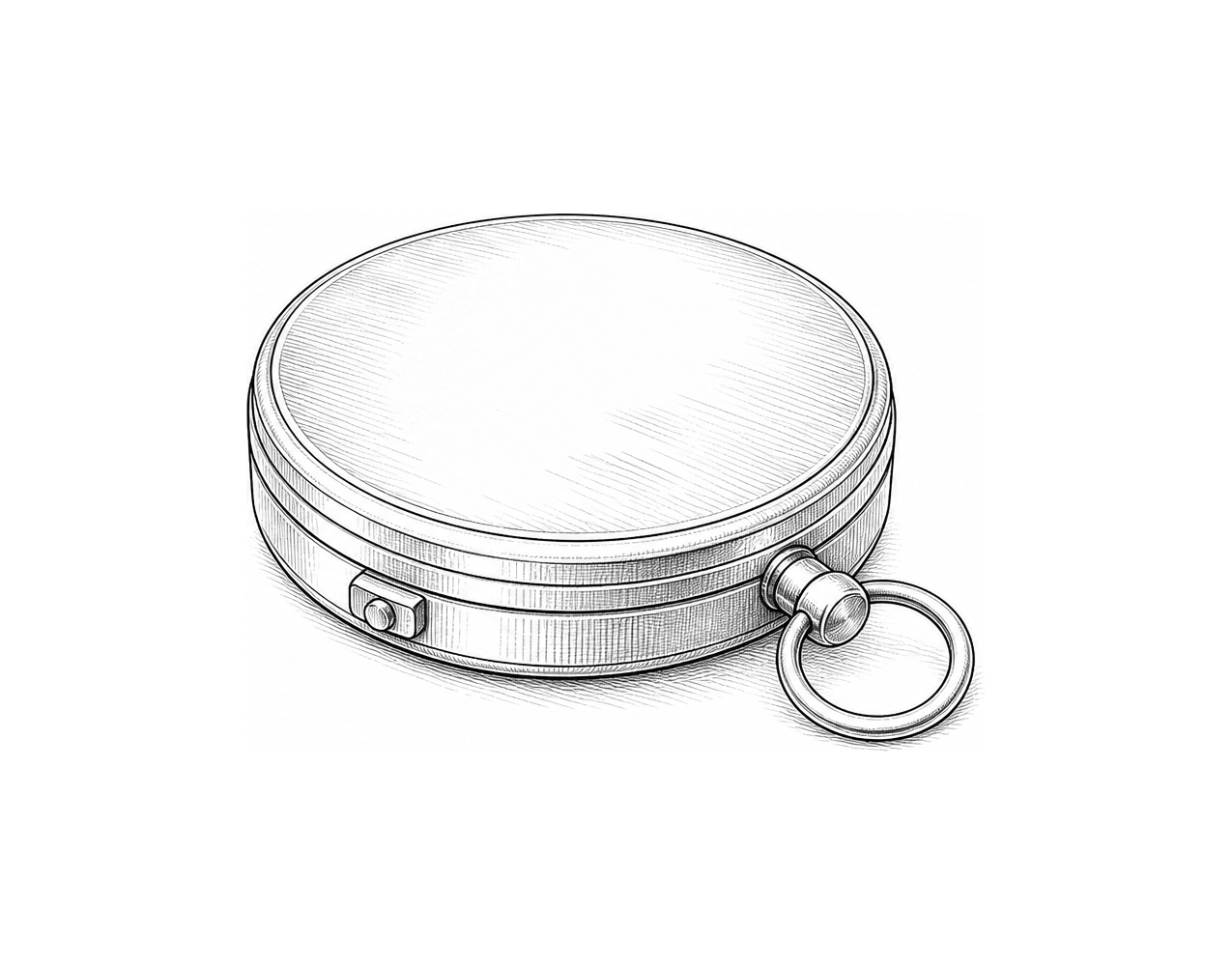

Challenge 2
The user should add two items in total. Ask for a second item, append it, then show all four items in the final packing list.

Challenge 3
Make a movie-night checklist. Start with two items of your choice, ask the user for a third, append it, and display the finished list with a clear heading.

Lists

Fix the code!

This code has errors! Look closely at the code to find the problems:

item = input("Pack one item: ")
packing_list = ["water", "map"]
packing_list.append(missing_item)
print("Packing list:", packing_list)

Rewrite the whole program in the box below with fixes to the errors.
Click or tap here to enter text.

After you are confident that you fixed all the errors, copy the code from the box and run it.

Did it work correctly on your first try? Did you find all the errors?
Click or tap here to enter text.

